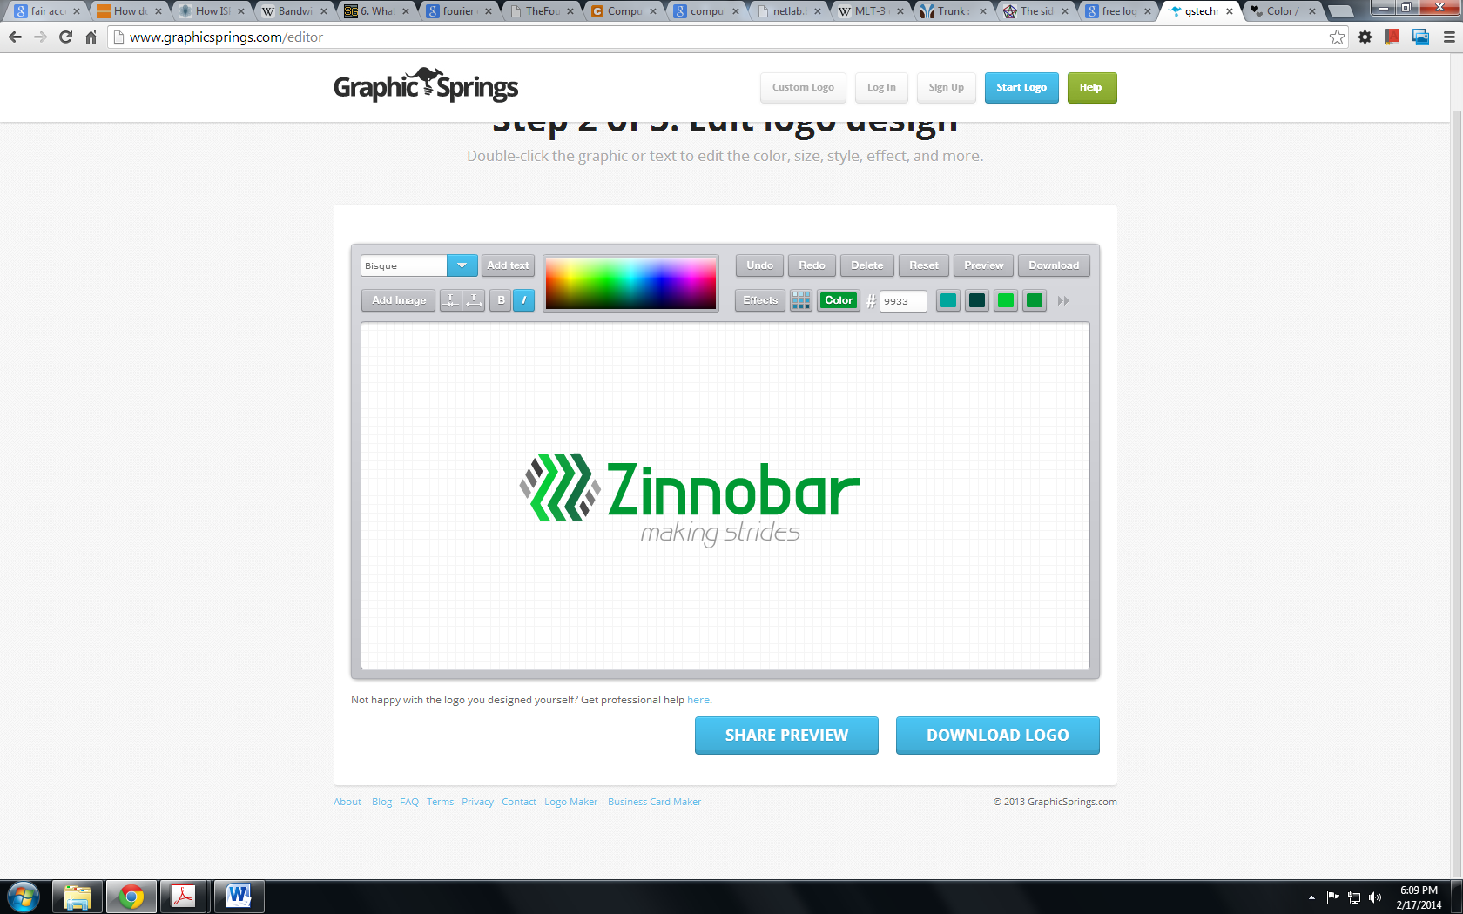

Collision Detection Specification

PHYSICAL REQUIREMENTS

* We require a total of 8 individual collision sensors, to be placed around an octagonal robot of 8” length. Each side of the octagon is 3.314”. Our robot has a chassis that is measured at a height of 2.25” from the ground to the top of the chassis.
* Each collision sensor must be based on a simple rocker button, with a foam panel attached. The button is sitting vertically, with the rocker switched angled down towards the ground.
* Each foam panel should be 3” wide, and go down to 0.5” off of the ground, when the button is sitting on top of the chassis.
* Each switch must be sitting in a mounting hardware so as to correctly interface with our bot. This mounting hardware must consist of a foam panel that is 3” long, and 0.5” wide. This will be attached to each side of the octagon bot upon completion. The rocker switch must be mounted on the center of the long side of this mounting hardware. Each rocker switch must also have some piece of hardware, whether it is a screw or a bolt, or something else, that runs through the small hole channel on the bottom of switch, and interfaces with the mounting hardware to make it stay on more secure.
* The three terminals on the switch must all be easily accessible when sitting in the mounting hardware, and none of them may be obstructed to the point of disuse. They also may not have any sort of material attaching between them on an individual switch.

ELECTRICAL REQUIREMENTS

* Each sensor panel will be individually interfaced with a digital in port on the Arduino, attached to a 5 volt source. When the switch is closed, the digital in will thus get a read of 5 V, read as high.

MILESTONES

Milestone 1: We require one working switch, with panel, and mounting hardware, proven to work as a functional switch when interfaced with a digital in on an Arduino, by no later than February 25, 2014. If this milestone is not reached, for each day of lateness we will require a personal meeting with our outsource team.

Milestone 2: We require 4 completed switches, with panels, and mounting hardware, proben to work as functional switches when interfaced with a digital in on an Arduino, by no later than March 4, 2014. If this milestone is not reached, for each day of lateness, we will require a supervised workshop of our outsource team, during which we will be monitoring their work for at least one hour a day.

Milestone 3: All 8 finished switches, by March 11. If this milestone is not met, then we will tell Ron Lasser that they were a crappy team to work with and that they should get a big ol’ F. Also, we will make them work in Halligan until they are done, no sleeping, eating, or leaving.